You an use following for build periodically in ant freestyle project

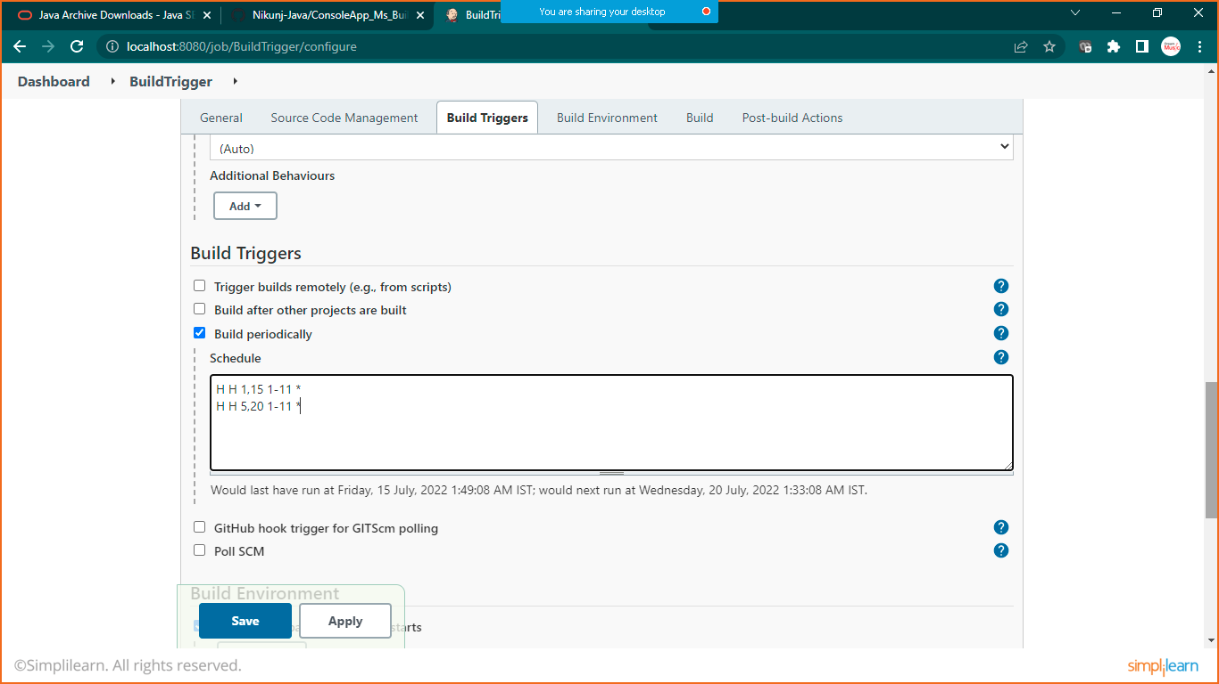

Or you can use Pol HCM for **Continuous Integration**

